Feedback after testing

27-9-2026
Login as a Manager
user : umermanager
pass : umermanager

- There should be a contact number column in orders page as well (just check it’s already with the customer name ok fine)
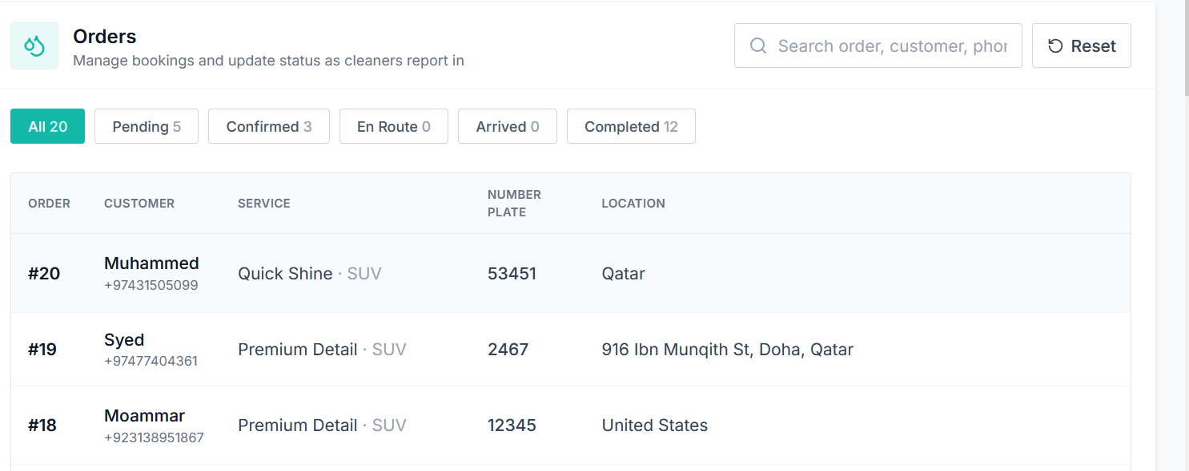

- Copy location feature similarly added to pick2Fix Project should be added in it
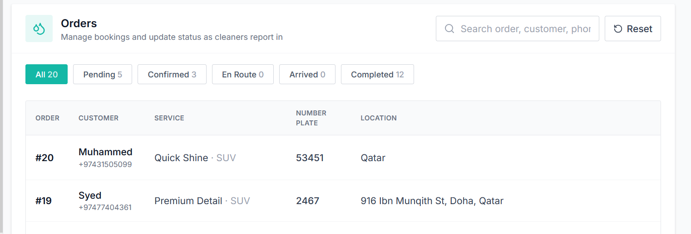

- Can we clean the data from admin side ,,, the records ?
- Need to see the daily, weekly and monthly financial reports financial
- Please don’t give the access to manager to change the prices for now it’s only for admin (will do it later)
- Need to give this order data to cleaner ,,, need to figure out how it can be get this done ,,, we need a template basically
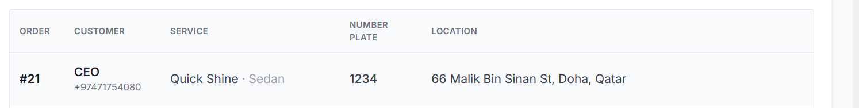

Login As a Admin
- In Active cleaners its shows managers data please check
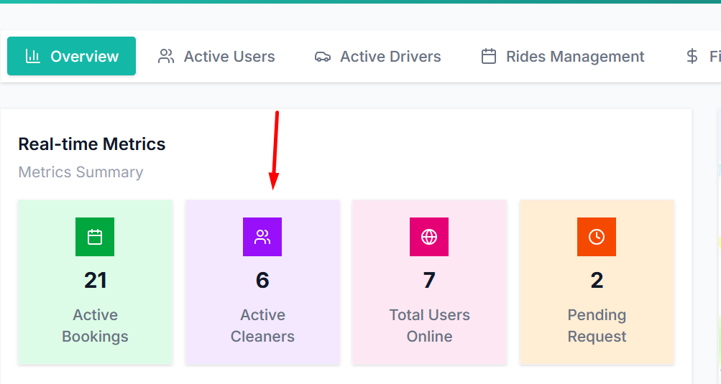
- Showing dollar sign in some places
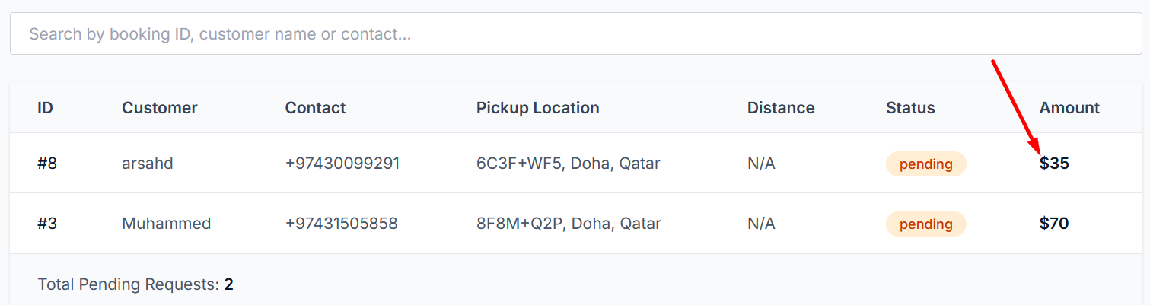

Done things

- Price controlling is working good ,, once I changed a price as a manager it reflect a right price
- Bookings are working perfectly fine ,,,
- Bookings reflecting on dashboard is working perfectly fine
- Connection of the app with the dashboard is really awesome

